Biography of Russ Breault

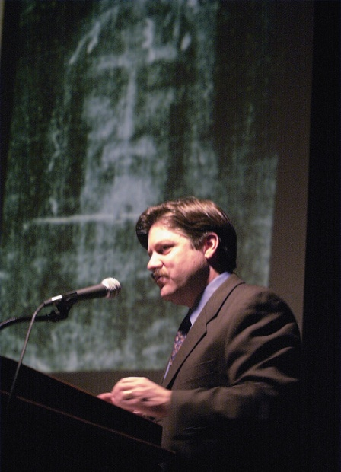

RUSS BREAULT has been researching and lecturing on The Shroud of Turin for over 30 years. His highly acclaimed presentation known as Shroud Encounter makes use of over 200 superb images and unfolds like a CSI investigation. The audience is intrigued as each clue is revealed and becomes another piece of a grand puzzle as the mystery of the Shroud is explored. Carefully designed to be educational and entertaining, he delivers a dynamic, fast-paced experience.

Russ Breault has presented to hundreds of audiences from New York to Hawaii. College and university presentations include Duke, Johns Hopkins, Penn State, Cal State and many others.

He has appeared in several nationally televised documentaries including Mysteries of the Ancient World on CBS. Most recently, he appeared in the highly acclaimed, Uncovering the Face of Jesus —A two-hour documentary on The History Channel. Mr. Breault was both advisor and a primary expert for this groundbreaking program. He was a primary expert for EWTN’s documentary, The Holy Winding Sheet. He has also been interviewed for Good Morning America and World News Tonight and was a consultant for CNN’s Finding Jesus episode on the Shroud.

He hosted and produced 12 episodes of The Shroud Report, a half-hour interview show with the world's leading experts.

He has participated in over a dozen international research symposiums since 1981 and three public exhibitions in Turin, Italy in 1998, 2000 and 2010.

He is a long-time member of the Shroud Science Group, an international consortium of scientists and scholars dedicated to further research.

Mr. Breault is the president and founder of the Shroud of Turin Education Project Inc., the mission of which is to: “Advance the knowledge of the shroud to a new generation.”
www.ShroudEncounter.com

